

**NORAD Myanmar Hpruso, Saw, Min Bu, and Pakkoku Townships IDELA Baseline 2017**

December 2017

**Jonathan Seiden & Sridevi Srinivasan**

**Table of Contents**

Executive summary 3

Introduction 3

Background 3

Research questions 3

Methods 4

Measurement 4

Data collection & sample 4

Technical Performance of the IDELA child tool 5

Internal Reliability 5

Variation by township and school 6

Analysis 7

IDELA Child Assessment results 7

Motor Development 9

Emergent Literacy 10

Emergent Numeracy 11

Social-Emotional Development 11

Executive Function and Approaches to Learning 12

Relationships with early learning and development 13

Age 13

Gender 14

Township 14

Limitations & recommendations 17

Conclusion 17

Appendix A: Subtask and domain summary statistics 18

Appendix B: Internal consistency of the IDELA Child Assessment 19

Appendix C: Model predicting IDELA Domains 20

# Executive summary

This report reviews results from the first implementation of the International Early Learning and Development Assessment (IDELA) in Myanmar. Save the Children staff assessed 624 children in 48 schools in four townships where Save the Children implements NORAD programming. Three townships (Min Bu, Pakkoku, and Saw) are in Magway Region, and comprise primarily Burmese speaking children. Hpruso Township from in Kayah State of East Burma consists primarily of minority language speakers.

We find that the IDELA instrument performed well from a psychometric perspective. Internal consistency of the tool is strong (overall Cronbach’s Alpha = .87). All core domains were significantly correlated with each other as expected, though not quite as strongly as in other datasets. Challenges may have been presented by the linguistic diversity and the overall high age of children.

Regarding relationships within the dataset, we find some significant gaps between boys and girls. Girls performed significantly better than boys on the overall assessment, a result that was driven largely by a wide gaps between boys and girls in the Emergent Literacy domain. We also find striking differences in the early learning and development of children between townships. Children from Hpruso Township, where a large proportion of children are from ethnic and linguistic minorities, exhibit much lower early learning and development outcomes than their Myanmar-speaking peers.

# Introduction

## Background

This report examines the early learning and development of 624 children in four townships of Myanmar. Save the Children is implementing programming in 347 schools in Myanmar. These schools are receiving programming through NORAD funding which includes support to teachers in the implementation of the new kindergarten methodology, additional trainings to make kindergarten classrooms inclusive and safe, setting up and resourcing of community libraries and working with and developing the capacity of the township education offices to strengthen systemic linkages.

This research is not an impact evaluation, but utilizes Save the Children’s presence in communities to explore differences in early childhood development by gender, age, and geography.

Save the Children developed the IDELA tool in response to the lack of a valid, rigorous, and easy-to-use methods of assessing early childhood development in low and middle income countries. Since its public release in 2014, IDELA has been used in over 40 countries. This report summarizes the first results from As such, this pilot test is also a test of the instrument itself in a new context.

## Research questions

The key research questions explored in this report include:

1. What skills do children demonstrate (and not demonstrate) on the IDELA assessment?
2. How are children’s early learning and development related to gender, township, and age?
3. How well does the IDELA assessment function as a tool of early learning and development in Myanmar context?

# Methods

## Measurement

The IDELA Child Assessment was used to measure children’s early learning and development with direct observation. In Burmese areas, the tool was administered exclusively in Myanmar language. In ethnic minority areas, field team members who could speak the local language administered the same tool translating it to explain questions to children. It is to be noted that the medium of instruction is Myanmar even in ethnic areas so children are exposed to Myanmar language when they enter the kindergarten year though they may not in anyway be proficient or comparable to a native Myanmar speaking child.

Items included in IDELA are listed in .

**Table 1. IDELA Child Assessment Subtasks**

|  |  |  |  |  |
| --- | --- | --- | --- | --- |
| Motor Development | Emergent Literacy | Emergent Numeracy | Social-Emotional Development | Other items |
| Hopping | Print Awareness | Comparison by Size and Length | Friends | Approaches to Learning |
| Copying a Shape | Oral Vocabulary | Sorting and Classification | Emotional Awareness/Regulation | Inhibitory control |
| Drawing a Person | Letter Identification | Number Identification | Empathy/Perspective Taking | Short-term memory |
| Folding Paper | Emergent Writing | Shape Identification | Sharing/Solving Conflict |  |
|  | First Letter Sounds | One-to-One Correspondence | Self-Awareness |  |
|  | Oral Comprehension | Addition and Subtraction |  |  |
|  |  | Puzzle Completion |  |  |

## Data collection & sample

The IDELA child assessment was conducted in-person by Save the Children staff in 48 schools in four townships of Myanmar. Three townships (Min Bu, Pakkoku, and Saw) are in Magway Region, and students in these townships are primarily Burmese speaking. Hpruso Township from in Kayah State of East Myanmar consists primarily of minority language speakers.

Within each township, 12 schools were selected randomly. Within each school, the sample was taken from a random selection of the grade 1 class attendance list. As such, data at the township level should be considered representative of the schools in which Save the Children operates. To ensure a sufficient sample of non-Burmese speakers, Save the Children interviewed up to 18 students per school in Hpruso Township schools, and up to 12 students per school in Burmese speaking areas. The result is a larger sample from Hpruso Township as shown in **Table 2**.

**Table 2. Gender composition of sample by township**

|  |  |  |  |  |
| --- | --- | --- | --- | --- |
| Township | Girls | Boys | Total | Average age |
| Pakkoku | 71 (49%) | 73 (51%) | 144 | 6.40 |
| Min Bu | 70 (49%) | 74 (51%) | 144 | 6.57 |
| Saw | 65 (46%) | 76 (54%) | 141 | 6.54 |
| Hpruso | 85 (44%) | 110 (56%) | 195 | 6.89 |
| *TOTAL/Average* | ***291 (47%)*** | ***333 (53%)*** | ***624*** | ***6.62*** |

**Table 2** also reveals that while the gender composition varied slightly (but not significantly) by Township, there was significant variation in the age of students. The average age of students in Saw, Min Bu, and Pakkoku was not statistically different, but children in Hpruso were significantly older. The reason for the varying age range 6.40 to 6.89 is their time of admission into KG in June 2016. The Ministry of Education introduced the new kindergarten year in June 2016 as the first year of primary school. All 5 year olds were expected to enroll in the KG year. Since most children in Myanmar do not have ECCD exposure (current coverage is about 24% ) this is their first exposure to systematic activities and learning.

As **Figure 1** shows, the breakdown by gender reveals that a majority of students in the sample were male. The variation by Township was not significant, and all townships had percentages of girls that were statistically indistinguishable from 50%.

A large majority (87%) of children in the sample were 6 or 7 years old, with several children aged up to 12 years old and a single 5-year-old. While the age range presents a substantial amount of variation, nearly half of the children in the sample are older than the recommended age range for the IDELA child assessment. IDELA was designed for and is typically administered to children 3.5-6 years old.

**Figure 1. Composition of sample by age and gender (n=624)**

## Technical Performance of the IDELA child tool

The IDELA child assessment performed fairly well from a technical perspective across the sample. All domains were significantly correlated with each other, suggesting that they are measuring a cohesive construct of early childhood development consistent with IDELA’s performance in other countries.

### Internal Reliability

As **Table 7** demonstrates, the correlations between core domains range from a low of 0.3728 between Motor Development and Emergent Numeracy to a high of 0.6822 between Social-Emotional Development and Emergent Literacy.

**Table 7. Correlation coefficients of core IDELA domains (n=624)**

|  |  |  |  |  |  |
| --- | --- | --- | --- | --- | --- |
|  | **IDELA Total** | **Motor** | **Emergent Literacy** | **Emergent Numeracy** | **Social-Emotional** |
| **IDELA Total** | 1.0000 |  |  |  |  |
| **Motor** | 0.6947 | 1.0000 |  |  |  |
| **Emergent Literacy** | 0.8957 | 0.5409 | 1.0000 |  |  |
| **Emergent Numeracy** | 0.7439 | 0.3728 | 0.5753 | 1.0000 |  |
| **Social-Emotional** | 0.8383 | 0.3998 | 0.6822 | 0.4869 | 1.0000 |

Appendix A presents the results of an analysis of the overall tool’s internal consistency as measured by Cronbach’s Alpha. The overall tool had an alpha of 0.8701; this is slightly lower than the 0.9+ “Excellent” internal reliability often seen in iterations IDELA, but still within the “Good” range. The overall consistency of the test was high, but the domain scores present a mixed bag. While we find the Cronbach’s Alphas of Social-Emotional (0.7355) and Emergent Literacy (0.7355) domains to be in the “Acceptable” range, the Emergent Numeracy consistency is considered “questionable” at 0.6990 and the Motor Domain score is considered “poor” at 0.5231. The large number of older children (which may have led to potential ceiling effects in this domain) may be deflating these measures of internal consistency. In addition, variations in the adaptation of the tool, especially across linguistic contexts, should be carefully checked to ensure proper administration.

The higher than recommended age range is likely the greatest challenge to the validity of IDELA results in this context. Language considerations also may play a role and we should be cautious about the interpretation of results without further validation of the tool in this context. However, despite this caveats, the IDELA child assessment appeared to function well overall as a measure of early learning and development.

### Variation by township and school

Examining the intra-class correlation (ICC) of IDELA scores by school helps us understand if variation of children’s early learning and development is being driven by variation *between* schools or *within* schools. In essence, the ICC tells us the proportion of variance in Total IDELA score that can be explained by school-level factors. Looking at the entire sample of 624 children in 48 schools, we find an ICC of 0.4713. This extremely high value means that school-level variation is responsible for nearly 50% of the variation of children’s scores. However, as **Figure 2** shows, the variation between schools is much larger in Hpruso Township than in the other townships. Omitting Hpruso Township from the analysis brings the ICC down to 0.1192, meaning that within Pakokku, Min Bu, and Saw Townships, that there is not a substantial amount of between-school differences.

**Figure 2. Score Ranges by School and Township**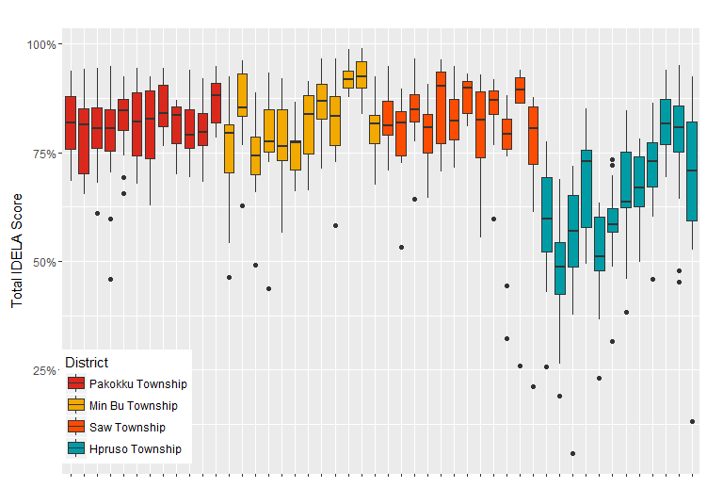

# Analysis

The primary purpose of this analysis is to investigate the status of children’s learning and development across the domains and subtasks of the IDELA Child Assessment and examine the relationship that learning and development status has with children’s background characteristics.

We first present a snapshot summary of the early learning and development status of the average child in the sample. We display the average scores of each subtask, and the composite scores that summarize children’s learning and development in the core domains of Motor Development, Emergent Numeracy, Emergent Literacy, and Social-Emotional Development. We then examine the relationships that exist between children’s IDELA scores and their gender, age, and township.

## IDELA Child Assessment results

The 22 core subtasks of IDELA are organized into the four domains of Motor Development, Emergent Numeracy, Emergent Literacy, and Social-Emotional Development. Domain scores are calculated as an average of subtask performance (the percentage of correct responses for each subtask). An unweighted average of domains is calculated to create a Total IDELA score to report children’s overall early learning and development.

In addition to the four core domains, assessors also mark additional short-term memory and inhibitory control items as a proxy for Executive Function and report observations on children’s persistence and engagement as a measure of their Approaches to Learning. These domains are less rigorously tested and validated than the core IDELA domains and are not yet part of the total IDELA composite. However, these observations can help provide a more holistic picture of children’s early learning and development.

Appendix B lists all subtask and domain average, standard deviation, and median scores.

**Figure 3. Total IDELA and core domain scores (n=624)**

As **Figure3** demonstrates, children’s scores were quite high across all domains. As the IDELA child assessment measures both the development of young children alongside early learning, the high scores may reflect the fact that the majority of children were 6 and 7 years old. Children performed best in the Motor Development domain and worst in the Social-Emotional Development domain.

**Figure 4 Distribution of Total IDELA Scores**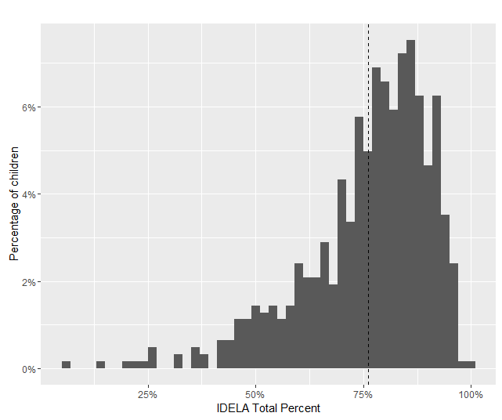

As visible in **Figure 4**, the distribution of IDELA scores shows that, while the average score was high and about half of students scored above 80% correct, there were many students who performed poorly. The long left tail of the distribution of IDELA scores reveals that, despite being older on average than the usual IDELA sample, many students lag in their early learning and development.

### Motor Development

As **Figure 5** demonstrates, the median child was able to complete each task perfectly, but average scores were lower. Overall, the Folding Paper subtask proved the most difficult on average. As mentioned before, the Motor Domain had the highest average score of any domain, with most children demonstrating strong developmental status in the domain, likely an artefact of the older age of the children in the sample.

**Figure 5. Motor domain subtask averages and medians (n=624)**

### Emergent Literacy

**Figure 6** **displays the mean and median scores of the Emergent Literacy subtasks.**

Overall, children demonstrated strong Early Literacy skills. The discrepancy between the mean and the median (with the median consistently higher than the mean) reveals that while a large share of children are performing well and demonstrating mastery of skills, a lot of children are performing substantially lower than would be hoped. Over half of children were highly print aware and could identify nearly all of the letters presented. Oral Vocabulary proved to be the most difficult task, with the average child able to name 6.5 vocabulary items in response to questions about animals and foods.

**Figure 6. Emergent Literacy domain subtask averages and medians (n=624)**

### Emergent Numeracy

As **Figure 7** demonstrates, children demonstrated strong Early Numeracy skills overall. As can be seen by the median scores, a majority of children got perfect scores on the comparison, shape identification, one-to-one correspondence, and addition and subtraction subtasks. The puzzle completion task proved the most difficult, with the average child getting only about half of the pieces in the right arrangement. In fact, only about 15% of children could complete the six-piece puzzle. The sorting and classification task also provided difficult. While most children could sort by at least one criterion (shape or color), most were unable to sort by a second criterion.

**Figure 7. Emergent Numeracy domain subtask averages and medians (n=624)**

### Social-Emotional Development

As **Figure 8** shows, subtasks within the Social-Emotional domain had a relatively narrow (and lower) range of average scores compared to the other domains. The Conflict, Emotional Regulation, and Friends subtasks proved to be the most difficult for children.

**Figure 8. Social-Emotional Development domain subtask averages and medians (n=624)**

### Executive Function and Approaches to Learning

As mentioned earlier, the IDELA child assessment also includes measures of short term memory and inhibitory control as proxies for Executive Function and observation items to assess children’s Approaches to Learning. While these items are less well validated than the core IDELA domains (and as such are not included in the composite score), we report on them in **Figure 9**. They exhibit similar trends to the rest of the assessment, with the exception of the Inhibitory Control task which children found particularly difficult.

**Figure 9. Executive Function and Approaches to Learning averages and medians (n=624)**

## Relationships with early learning and development

Children’s early learning and development is influenced by a number of factors. The following section examines the relationships between children’s IDELA scores and their age, gender, and township. We do not assert whether or not these variables *cause* differences in development, but these relationships can support hypotheses and highlight potential areas for intervention.

The IDELA Child Assessment is often partnered with the IDELA Home Environment tool to provide richer background data on the factors in children’s homes that may impact their development. In this analysis, we have only the data collected by enumerators at the time of the child assessment, and are therefore examining a more limited set of variables.

We use multivariate regression analysis to examine the relationships of these factors in tandem rather than simple bivariate relationships. The full details of our final models, including insignificant variables, can be found in tables in Appendix C.

### Age

IDELA scores do not exhibit a strong relationship with age across the sample. Using the entire sample of 624, we find that, on average, older students are not expected to score any differently than younger students. Due to this unusual finding and the overall older age of students, we investigated the relationship a bit more deeply. We restricted our sample to children 6-8 years old (which included 97% of the full sample). When looking at this restricted sample year by year, we find a slightly different situation. As **Figure 10** demonstrates, children aged 6 and 7 years old did not score differently from each other on any domain. However, 8 year old students did score significantly higher on several domains.

**Figure 10. IDELA and domain averages for 6, 7, and 8 year old children (n=605)**

We typically find a significant and positive association between IDELA scores and children’s age, even when the variation in the sample age is limited. The lack of a stronger relationship in this dataset is likely a result of the overall older age of students in the dataset. While there is good variation by age in the sample, there is little variation in the recommended age range of the IDELA assessment (3.5-6 years). Many of the skills tested by IDELA develop naturally over time at different rates, so we see a relationship between age and these skills during earlier ages. In this dataset, we are not picking up any of the variation of developmental skills.

Instead, the variation in scores that we are picking up is primarily on skills which must be explicitly taught and learned. For example, letter identification or simple addition and subtraction will not develop naturally. In these cases, the *grade level* may be more predictive of whether or not a student is able to do something than their age. Given that all students in the sample are in Grade 1, we find that there is little variation of what children have *learned* by their age.

### Gender

Gender was significantly related to children’s early learning and development scores. As **Figure 11** shows, girls performed significantly better than boys on the Total IDELA, after controlling for age and township. While boys and girls scored similarly on Emergent Numeracy and Social-Emotional Development, girls outperformed boys in the Motor Development domain. The largest gender gap was observed in the Emergent Literacy domain. Girls outperformed boys in Emergent Literacy by nearly 7 percentage points.

**Figure 11. IDELA Domain scores by gender, controlling for age and township (n=624)**

### Township

The results of the IDELA Child Assessment by township revealed the most striking differences in early learning and development and highlight a large and significant equity gap. As we can see in **Figure 9**, children in Pakokku, Min Bu, and Saw Townships did not differ significantly in their early learning and development from each other. However, in Hpruso Township, home to a majority of non-Burmese speaking students, students scored significantly lower.

**Figure 12. Average Total IDELA Score by Township**

This statistic becomes even more visible when examining the distribution of Total IDELA scores in **Figure 13**. Here we can see that not only is the average score significantly lower in Hpruso Township, but that the distribution of scores is much flatter, indicating that there is a wider range of early learning and development within Hpruso Township.

**Figure 13. Distribution of Total IDELA scores by township**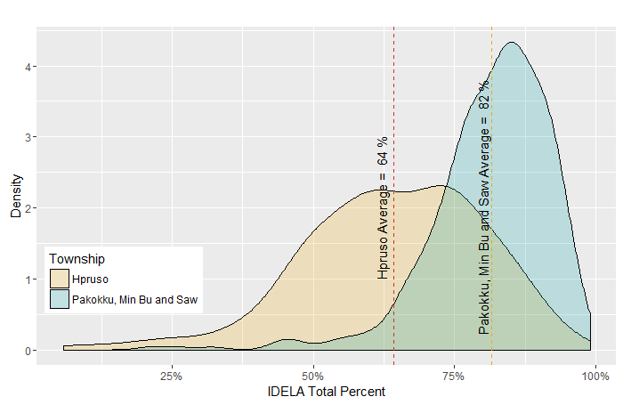

To illustrate this stunning gap, let us consider the median child from Hpruso Township. The median child in Hpruso is at the 50th percentile in Hpruso. That means that half of the other children in Hpruso scored higher than him or her, and half scored lower. However, if we moved that median Hpruso child into Pakkoku, Min Bu, or Saw Township, they would be at the 4.4 percentile. That means their score would be lower than over 95 percent of the children in those townships. The score of a child in the middle of the range in Hpruso is in the lowest 5 percent of scores in the other sites.

While there are no significant differences between Pakkoku, Saw, and Min Bu Townships on *Total IDELA* score, a breakdown by domain reveals some significant differences and highlights where children in Hpruso lag the most. **Figure 14** illustrates these differences. Compared to Pakkoku Township, children in Min Bu and Saw Township had significantly higher Motor Development scores. Students in Saw Township had significantly lower Social-Emotional Development scores than students in Pakkoku Township.

**Figure 14. IDELA core domains by Township**

As expected from the Total IDELA scores, children in Hpruso Township have significantly lower scores on every domain. However, the magnitude of this difference is substantially larger in Emergent Literacy and Social-Emotional Development than in Motor Development or Emergent Numeracy. Given the minority language status of the children in Hpruso, the result in the Emergent Literacy Domain is not a surprising result. Similarly, as the Social-Emotional Development subtasks rely more on language and communication than the Emergent Numeracy or Motor subtasks, they may be more sensitive to difficulties in communication.

We can also illustrate this massive gap using the results of a simple non-parametric replication analysis. Essentially, we randomly sampled two children from our dataset, one from Hprosu and one from Pakkoku, Min Bu, and Saw Townships. If children from each township have similar scores, then we would expect the child from Hprosu to have a lower score about 50% of the time. However, after repeating this test 100,000 times, we find that the child from Hprosu has a lower score over 83% of the time.

# Limitations & recommendations

The primary limitation of this study is the age of children involved. The lack of a relationship between age and IDELA scores was a surprising result. Given that more than half of the children in the sample were above the recommended age for IDELA, we may simply have limited room for comparison of developmental skills. Despite this limitation, the IDELA tool performed adequately and would likely perform even better if children were all within the 3.5-6 years old age range.

The most striking findings of the analysis are the equity findings surrounding the township. While we can describe the size and significance of these gaps, we cannot speak much about the reasons they exist. We should also carefully consider the language in which the assessment is being conducted. Without confirming consistent administration and the language used, it is difficult to assess whether the striking gaps in development are not simply errors due to language of assessment.

As a cross-sectional study, all results should be interpreted as correlational. While we find statistically significant relationships, we cannot interpret any causally.

Future studies would benefit from the addition of the IDELA Home Environment to better understand the family situations of children and what factors may influence their early learning and development. Future studies would also benefit from the introduction of inter-rater reliability measures to ensure that enumerators are scoring IDELA consistently.

# Conclusion

The IDELA Child Assessment was piloted for the first time in Myanmar during this study with 624 children from four townships. Overall, scores on the assessment were quite high, but the age of children was higher than is typically recommended for the IDELA assessment.

Importantly, children’s early learning development is significantly correlated with 1) gender and 2) township. Female students performed better on average, especially in the domain of Emergent Literacy. Students from Hpruso Township performed significantly worse on all domains, but particularly in Emergent Literacy and Social-Emotional Development. Surprisingly, we find that age did not significantly predict IDELA scores, but this may be because of the out-of-age range of about half of the students.

Finally, we find that the IDELA assessment performed reasonably well. Questions appeared to share a similar structure with its implementations in other countries, and the results did not call into question the conclusions draw from the use of IDELA abroad: that it is a rigorous, holistic, and valid measurement of children’s early learning and development.

# Appendix A: Internal consistency of the IDELA Child Assessment

|  |  |  |  |  |  |  |
| --- | --- | --- | --- | --- | --- | --- |
| Item | Obs | Sign | Item-test correlation | Item-rest correlation | Inter-item covariance | Alpha |
| Comparison by Size and Length | 624 | + | 0.3336 | 0.295 | 0.020365 | 0.8693 |
| Shape Identification | 624 | + | 0.4699 | 0.4154 | 0.019628 | 0.8661 |
| Sorting and Classification | 624 | + | 0.3505 | 0.2541 | 0.01969 | 0.8725 |
| Number Identification | 624 | + | 0.6053 | 0.5417 | 0.018591 | 0.8615 |
| One-to-One Correspondence | 624 | + | 0.6071 | 0.5528 | 0.018855 | 0.8617 |
| Addition and Subtraction | 624 | + | 0.5722 | 0.514 | 0.018981 | 0.8628 |
| Puzzle Completion | 624 | + | 0.4514 | 0.3565 | 0.019078 | 0.8691 |
| Self-Awareness | 624 | + | 0.6179 | 0.5805 | 0.019363 | 0.8629 |
| Friends | 624 | + | 0.4106 | 0.3273 | 0.019475 | 0.8691 |
| Sharing/Solving Conflict | 624 | + | 0.6242 | 0.5407 | 0.017889 | 0.8617 |
| Empathy/Perspective Taking | 624 | + | 0.6642 | 0.6038 | 0.018179 | 0.859 |
| Emotional Awareness/Regulation | 624 | + | 0.6411 | 0.5669 | 0.017971 | 0.8603 |
| Copy Shape | 624 | + | 0.4446 | 0.4038 | 0.020006 | 0.8672 |
| Folding Paper | 624 | + | 0.5009 | 0.4167 | 0.018896 | 0.8663 |
| Drawing a Person | 624 | + | 0.4118 | 0.3354 | 0.019556 | 0.8685 |
| Hopping | 624 | + | 0.3552 | 0.3084 | 0.020191 | 0.8688 |
| Oral Vocabulary | 624 | + | 0.7099 | 0.6672 | 0.018466 | 0.8582 |
| Print Awareness | 624 | + | 0.5387 | 0.4702 | 0.01895 | 0.864 |
| Letter Identification | 624 | + | 0.687 | 0.6382 | 0.01841 | 0.8586 |
| Emergent Writing | 624 | + | 0.5793 | 0.4894 | 0.018167 | 0.8641 |
| Oral Comprehension | 624 | + | 0.6433 | 0.5752 | 0.018132 | 0.86 |
| Test scale | |  |  |  | **0.018992** | **0.8701** |

# Appendix B: Subtask and domain summary statistics

|  |  |  |  |  |
| --- | --- | --- | --- | --- |
| Subtask/Domain | Mean | | Median | Standard Deviation |
| Comparison by Size and Length | 96% | 100% | | 13% |
| Shape Identification | 87% | 100% | | 21% |
| Sorting and Classification | 51% | 50% | | 32% |
| Number Identification | 79% | 95% | | 29% |
| One-to-One Correspondence | 85% | 100% | | 25% |
| Addition and Subtraction | 83% | 100% | | 25% |
| Puzzle Completion | 49% | 50% | | 34% |
| Emergent Numeracy | 76% | 79% | | 16% |
| Self-Awareness | 75% | 83% | | 18% |
| Friends | 65% | 70% | | 29% |
| Sharing/Solving Conflict | 63% | 50% | | 38% |
| Empathy/Perspective Taking | 75% | 100% | | 30% |
| Emotional Awareness/Regulation | 60% | 75% | | 35% |
| Social-Emotional | 68% | 72% | | 22% |
| Copying a Shape | 94% | 100% | | 15% |
| Folding Paper | 75% | 100% | | 32% |
| Drawing a Person | 84% | 100% | | 27% |
| Hopping | 94% | 100% | | 16% |
| Motor | 87% | 91% | | 15% |
| Oral Vocabulary | 65% | 65% | | 25% |
| Print Awareness | 85% | 100% | | 28% |
| Letter Identification | 81% | 95% | | 26% |
| Emergent Writing | 68% | 75% | | 38% |
| Oral Comprehension | 71% | 80% | | 33% |
| Emergent Literacy | 74% | 78% | | 21% |
| Short-term Memory | 93% | 100% | | 15% |
| Inhibitory Control | 68% | 80% | | 33% |
| Executive Function | 81% | 88% | | 19% |
| Overall Observation | 77% | 79% | | 15% |
| Persistence/Motivation | 89% | 100% | | 17% |
| Approaches to Learning | 83% | 87% | | 14% |
| Total IDELA | 76% | 79% | | 15% |

# Appendix C: Model predicting IDELA Domains

|  |  |  |  |  |  |  |  |
| --- | --- | --- | --- | --- | --- | --- | --- |
|  | Motor | Emergent Literacy | Emergent Numeracy | Social-Emotional | Executive Function | Approaches to Learning | Total IDELA |
| Age in Years | -0.006 | -0.004 | 0.013 | -0.003 | -0.018 | -0.002 | 0.000 |
| Female | 0.024* | 0.067*** | -0.002 | 0.001 | 0.002 | 0.028* | 0.022* |
| Min Bu Township | 0.079*** | -0.017 | -0.030 | -0.025 | -0.000 | 0.061** | 0.002 |
| Saw Township | 0.046** | 0.014 | -0.002 | -0.055* | -0.099** | 0.090*** | 0.001 |
| Hpruso Township | -0.066** | -0.247*** | -0.091** | -0.281*** | -0.092*** | 0.030~ | -0.171*** |
| Constant | 0.888*** | 0.815*** | 0.706*** | 0.804*** | 0.975*** | 0.789*** | 0.803*** |
| R-squared | 0.149 | 0.335 | 0.058 | 0.311 | 0.074 | 0.063 | 0.299 |
| Observations | 624 | 624 | 624 | 624 | 624 | 624 | 624 |

Note: ~ = p < 0.10; * = p < 0.05; ** = p < 0.01; *** = p < 0.001)

Errors are clustered at the school level.